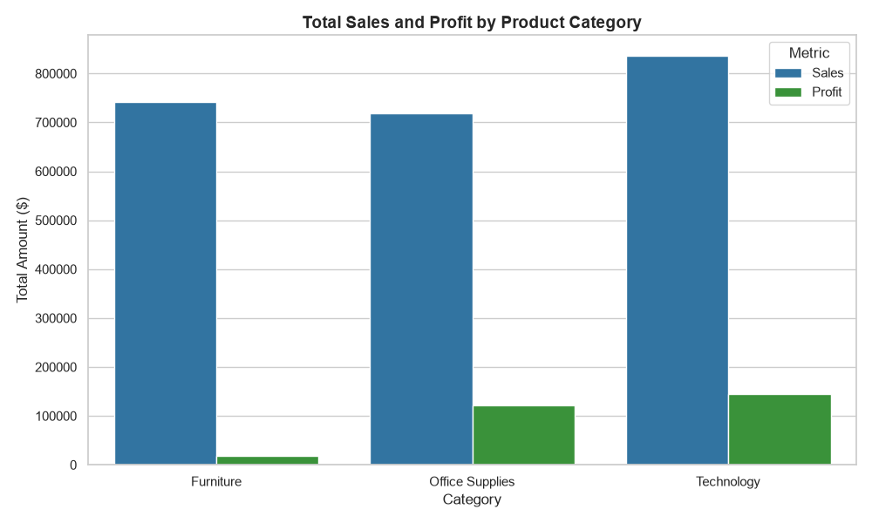
Exploratory Data Analysis (EDA)
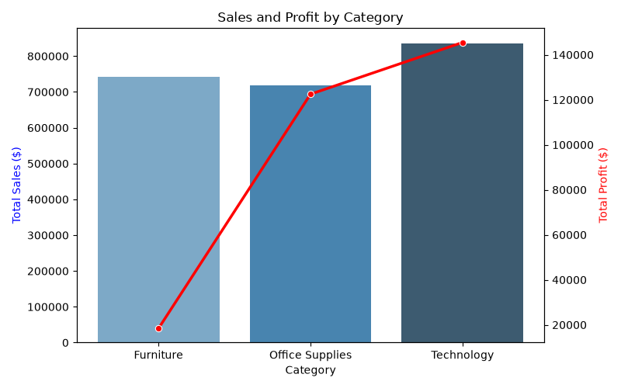
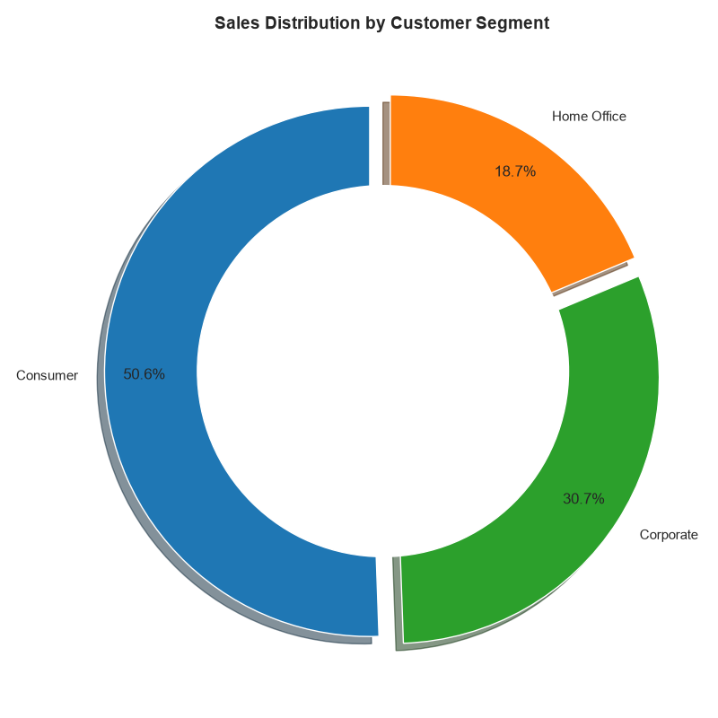
DATA Visualization
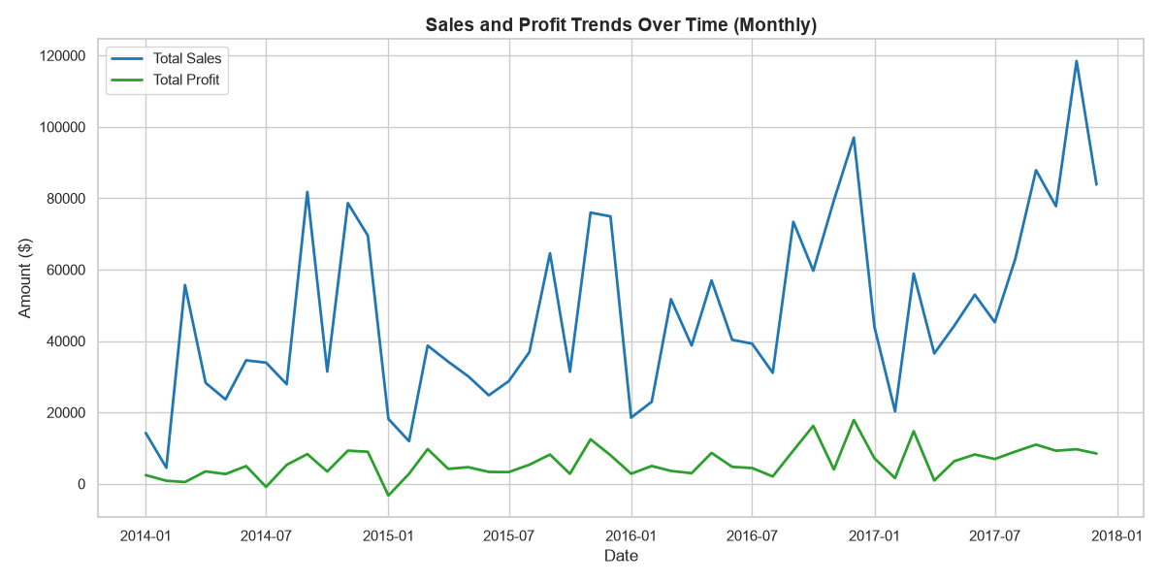
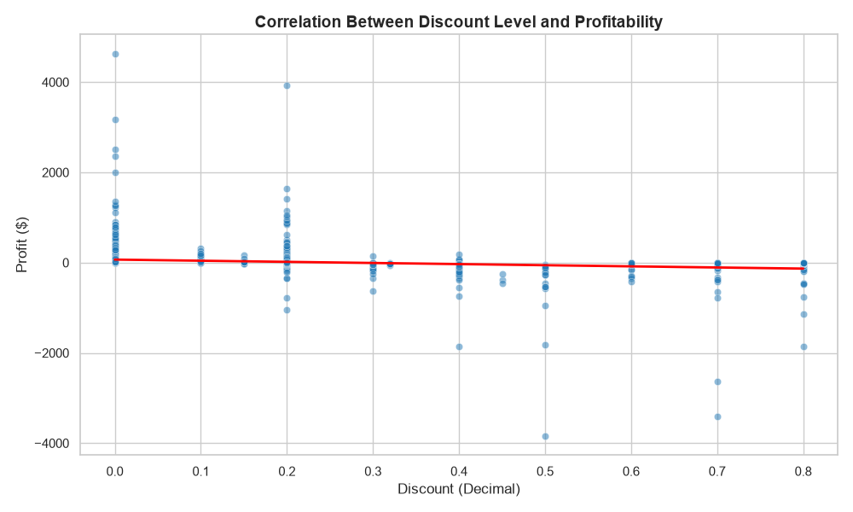

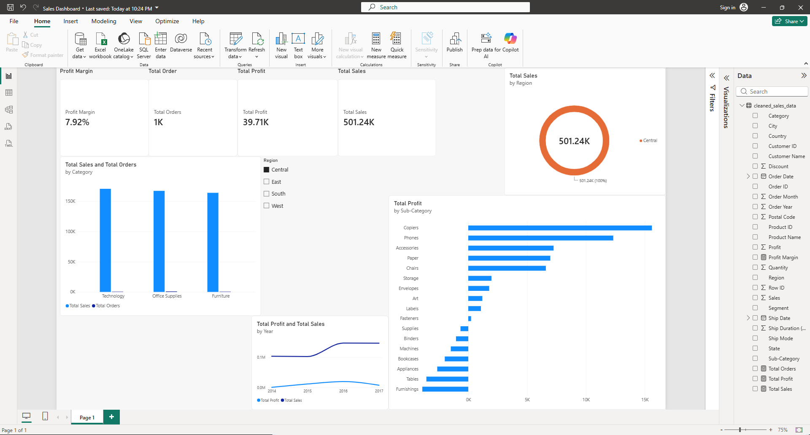
Power BI Dashboard
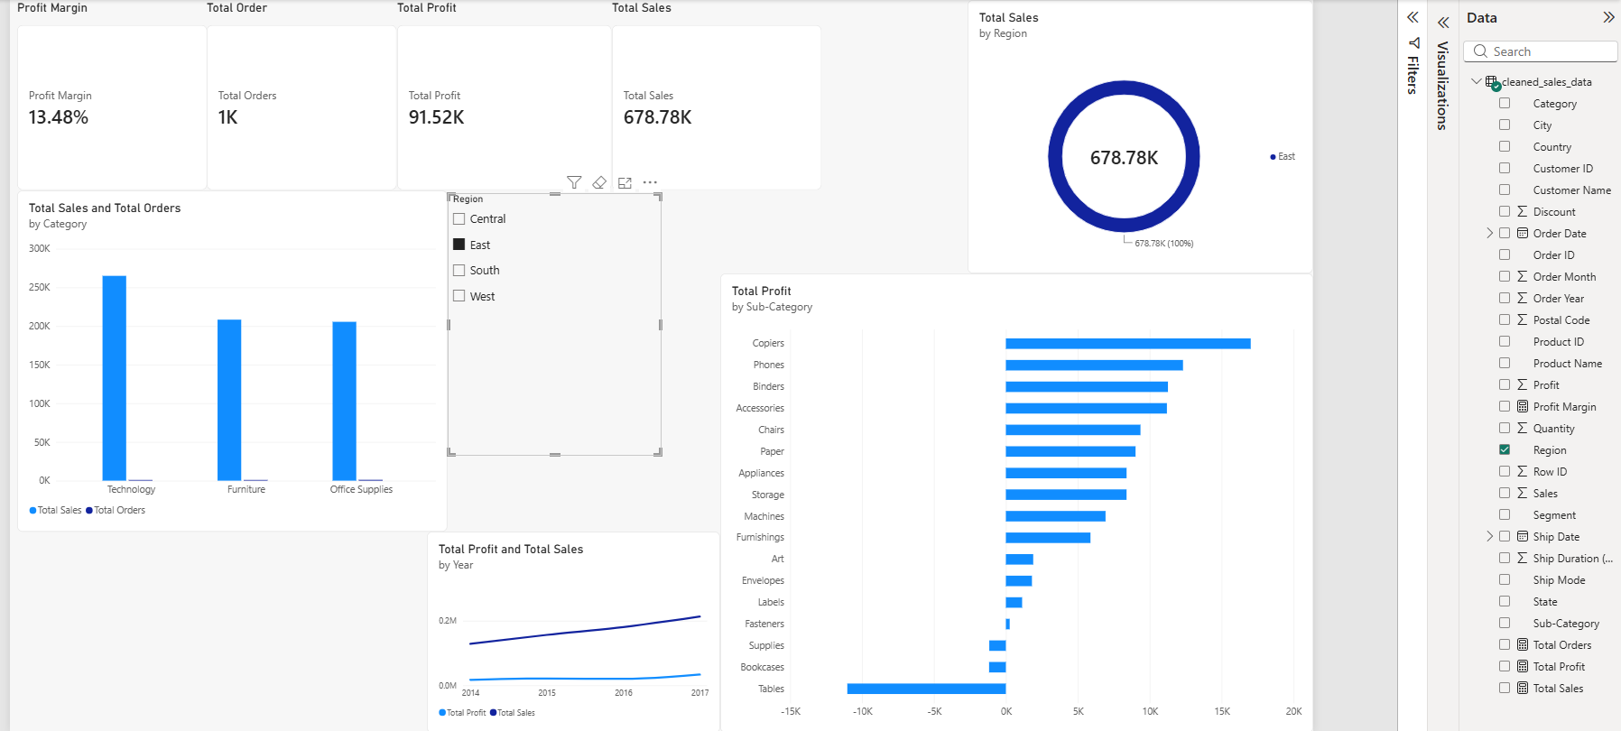
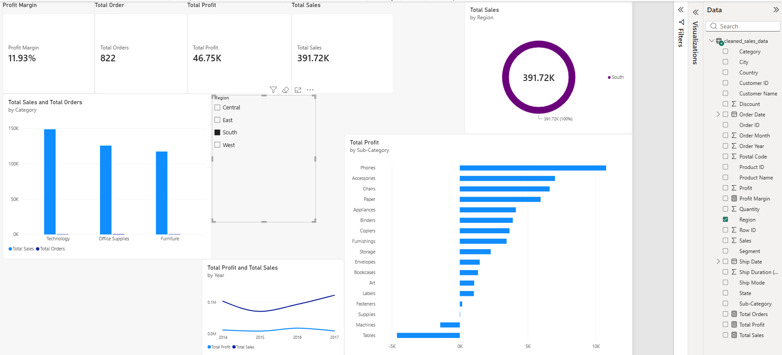
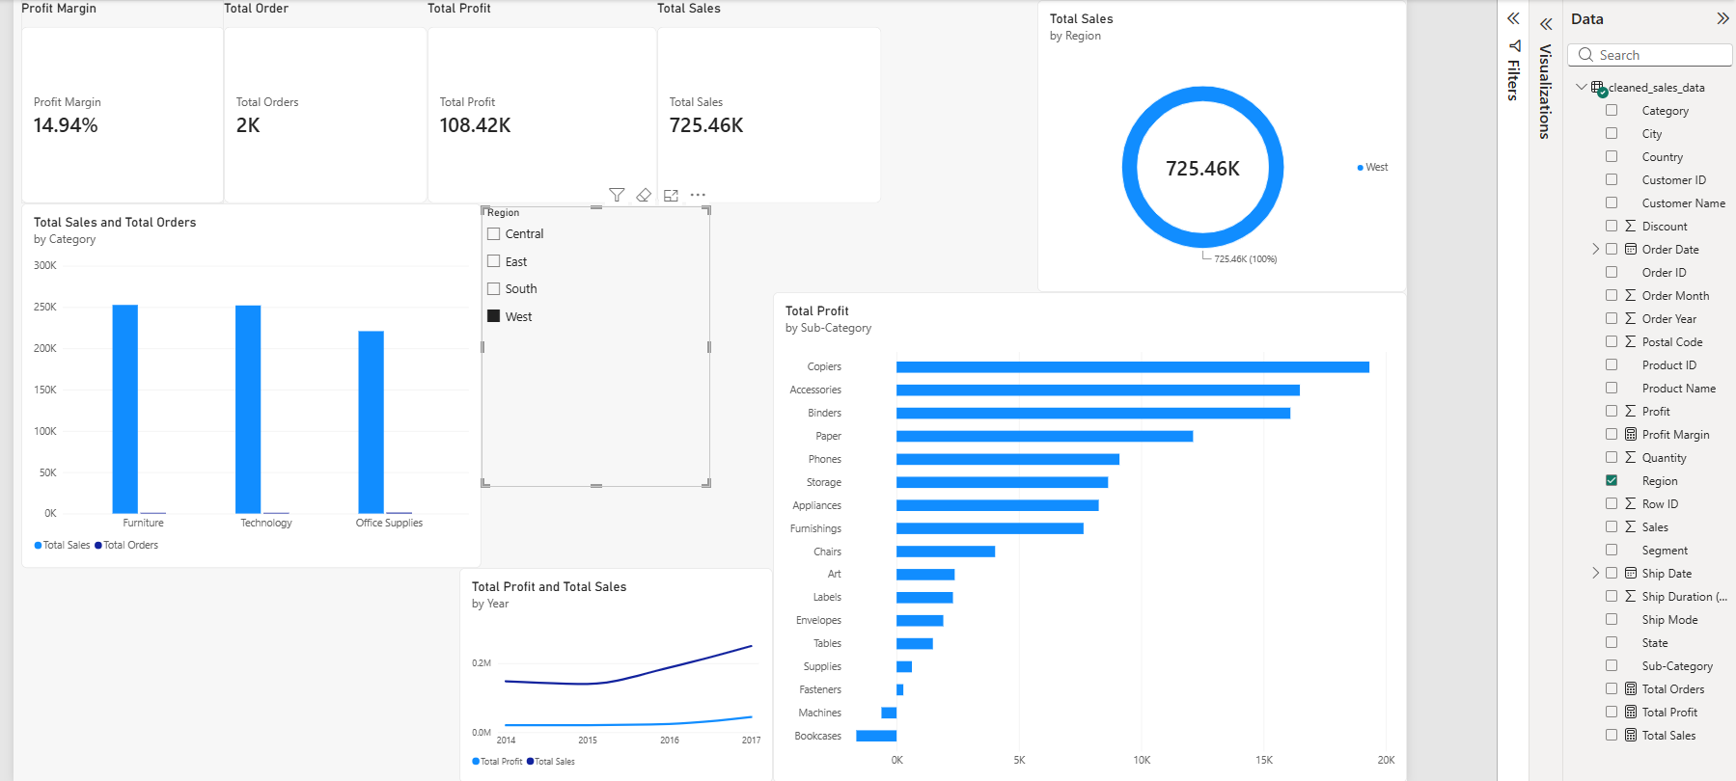

Business Insights & Recommendations Report
1. High-Level Executive Findings
- Total Portfolio Revenue: $2,297,200.86 across 5,009$ unique orders.
- Overall Net Profit: $286,397.02, delivering an aggregate profit margin of 12.47%.
- Core Profit Driver: Technology generates $145,454.95 in profit ($50.8% of total company profit) from $836,154.03 in sales.
2. Five Meaningful Business Insights
- Insight 1: High Promotional Discounting Directly Destroys Profitability
  - Transactions with 0% discount generate a 29.51% profit margin $320,987.60 profit on $1.09M sales).
  - Discounts of 20% maintain a sustainable profit margin of 11.82%.
  - Any discount level ≥30% turns transactions heavily negative. Orders discounted at 30% produce a -10.05% profit margin, while discounts of 70%–80% result in extreme losses (up to -180.03% margin).
- Insight 2: Furniture Category Suffers from Severe Margin Compression
  - Despite generating substantial top-line revenue ($741,999.80), Furniture yields only $18,451.27 in total profit—a sub-par 2.49% profit margin.
  - High average discounts across Furniture sub-categories (e.g., 26.13% on Tables and 21.11% on Bookcases) erode profitability.
- Insight 3: High-Performing vs. Loss-Making Sub-Categories
  - Top Profit Contributors: Copiers ($55,617.82 profit, 37.20% margin), Phones ($44,515.73), and Accessories ($41,936.64) lead product profitability.
  - Loss-Making Lines: Tables (-$17,725.48 net loss), Bookcases (-$3,472.56 net loss), and Supplies (-$1,189.10 net loss) actively drain business capital.
- Insight 4: Regional Margin Disparities (Central Region Bottleneck)
  - The West region leads both in volume ($725,457.82 sales) and profitability ($108,418.45 profit, 14.94% margin).
  - The East region achieves a strong 13.48% margin ($91,522.78 profit).
  - The Central region exhibits the lowest operational efficiency, generating only 7.92% profit margin ($39,706.36 profit on $501,239.89 sales) due to aggressive promotional discounting in those states.
- Insight 5: Customer Segment Profitability Gradient
  - Consumer represents the largest market share (50.56% of sales / $1,161,401.34), but yields the lowest segment margin at 11.55%.
  - Home Office produces the highest margin at 14.03% ($60,298.68 profit on $429,653.10 sales), indicating higher pricing tolerance and lower discount reliance.
3. Data-Driven Business Recommendations
Recommendation 1: Implement Strict Discount Caps & Eliminate Unprofitable Promotions
- Action: Restrict maximum baseline discounting to 15%–20% across all product categories.
- Target Area: Immediately abolish discounts exceeding 30\% on Tables, Bookcases, and Binders.
- Expected Impact: Reclaiming lost margins on discounted transactions will eliminate over $100,000 in net promotional losses and increase overall company profit margin from 12.47% to over 18%.

